**REPORT BY**

**NAME:KUSHAL SHAH**

**STUDENT ID:A20207420**

**EMAIL ID:kusshah@okstate.edu**

**Non technical Section:**

**Main Causes for Non- Fatal injuries:**

* **Reason 1**)Pilot’s failure to maintain directional control of aircraft.
* **Reason 2**)unsuitable selection of runway for takeoff and unsuitable conditions associated with mountain terrain, weather at altitude
* **Reason 3**)Failure of right and left landing gear and nose wheel due to system’s fatigue.
* **Reason 4**)Loss of Engine Power, forced landing on unsuitable terrain.
* **Reason 5**)Improper wind condition and Flight instructor’s inability to supervise student pilot resulted in misjudgments of landing flare and hard landing
* **Reason 6**)Exhaustion of fuel supply which resulted in forced landing.
* **Reason 7**)Failure to maintain control of aircraft and subsequent collision with terrain.

**Summary** : For non-fatal Accident category, we can conclude that there were some reason such as exhaustion of fuel which resulted in loss of engine power and harsh wind and weather condition which resulted in Force landing.

* Pilot’s inability to maintain directional control, Failure of right and left landing gear and nose wheel due to system’s fatigue, unsuitable selection of runway, improper supervision and Pilot’s misjudgments of landing flare and lack of fuel refilling alongside harsh weather condition were some of the contributing reasons behind these injuries.

**Main Reasons for Fatal Accident:**

* **Reason 1**:Pilot’s lack of experience to control aircraft and subsequent airplane’s inadvertent stall/spin of aircraft.
* **Reason 2**:Undetermined separate plan for safety and loss of control due to failure of right rotor resulted in fatal accident.
* **Reason 3**:Harsh condition of flight instruments and pilot’s decision to continue fly without control despite of dark night and bad weather resulted in fatal accident.
* **Reason 4**:Failure to maintain clearance from terrain, failure to maintain visual lookout by two pilot at altitude which resulted in collision of two aircraft-fatal accident.
* **Reason 5**:Fast Landing due to Exhaustion of fuel and undetermined reason behind loss of engine power.
* **Reason 6**:Pilot’s failure to maintain adequate airspeed which resulted in fatal accident.
* **Reason 7**:Flight at low altitude failed to maintain clearance from ground, dark night visual resulted in fatal accident.

**Summary**: Some of main reasons are Flight’s adequate speed, inadequate ground clearance, inadequate distance from obstacle, failure to maintain visual lookout by pilots, Pilot’s lack of experience, dark night visual and bad weather condition.

**Note: All of the above cited are common reasons for different conditions.**

**Recommendations**: Provide more training to pilots to make them capable to fly in dark night, and bad weather

condition to fly.

* Always be prepared with separate safety plan for accidents.
* Provide sufficient training to pilots regarding having clearance, maintaining airspeed and take off.
* Provide sufficient knowledge regarding fuel need and control system in flight to pilot.
* Always check flight system’s condition, landing gear and wheel condition in aircraft before flight.
* Always follow weather forecasting to avoid emergencies in bad weather.
* Provide sufficient maintenance to aircraft components on timely basis.

**Note:(Above Recommendations has been given based on the reasons provided for fatal and non-fatal accidents.)**

**Technical Details**:

**Note: Here reasons are given for two separate categories of accident(involving Fatal injuries and involving non-fatal injuries)**

**Explanation of Reasons for Non-Fatal injuries**.

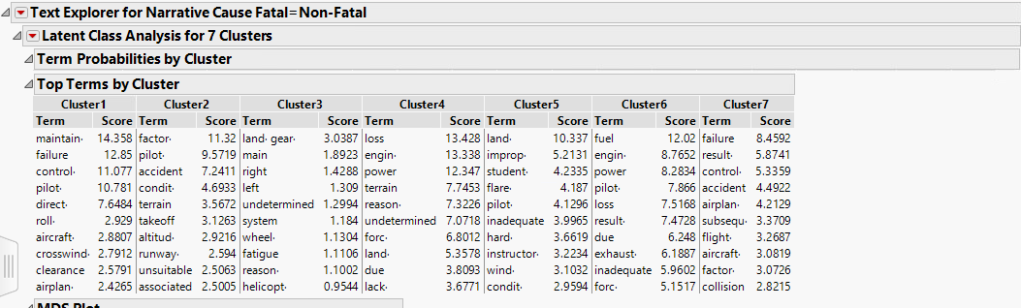 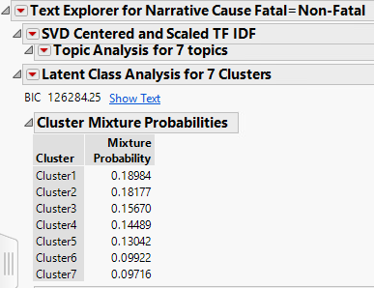

**Fig-(1-a)** **Fig-(1-b)**

Fig-(1-a) shows **clusters** of documents which are related with same topics. Score of each term in each cluster reflects the importance of that particular term in defining meaning from respective cluster. Top 10 most important term from every cluster has been shown in Fig-(1-a) . Documents has been clustered with respect to similarity of topics in between documents. Probability*100 in Fig-(1-b) shows % of total documents in each term. Here each of 7 reasons has been derived from different 7 clusters(e.g:**Reason 1 from Cluster 1**)

* **Reason 1 explanation**: From scores in **cluster 1**, we can infer that the cause might me related to failure to maintain control. Terms like ‘direct’, ‘aircraft’, ‘pilot’ suggest directional control and control of aircraft respectively. That’s why, Reason might me related to ‘**Pilot’s failure to maintain directional control of aircraft’**.
* **Reason 2 explanation** : Terms like ‘takeoff’, ‘runway’, ‘unsuitable’, ‘Pilot’ in **cluster 2** suggest ‘**Pilot’s unsuitable selection of runway terrain for takeoff**’. Term ‘altitude’ suggest about some conditions at high altitude. Combining this with terms ‘factor’,’accident’, ‘associated’, we get ‘**Factors associated to accident are related to Pilot’s unsuitable selection of runway terrain for takeoff and condtions at high altitude**’ as a **reason 2**.
* **Reason 3 explanation** : ‘land gear’, ‘right’, ‘left’ are the most important term in determining reason from **cluster 3**. Combining these terms with ‘failure’ and ‘wheel’ suggest that **‘Failure of right and left landing gear and nose wheel’. Terms-‘fatigue’ and ‘systems’ suggest ‘some fatigue in system’** .We get our **reason 3** as ‘**Failure of right and left landing gear and nose wheel due to system’s fatigue**.’ by combining those two.
* **Reason 4 explanation**: The highest important term in **cluster 4** are ‘loss’, ‘engine’ power’. These term cites ‘**Loss of power in Engine’** as one of the key reason behind the injuries. Terms like ‘forced’ , ‘land’, ’terrain’, ‘unsuitable’ suggest **‘Forced landing on unsuitable terrain/land’** as a secondary reason as well (**cited in Reason 4**).
* **Reason 5** explanation :We can infer ‘**Flight instructor’s inability to supervise student pilot resulted in misjudgments of landing flare and hard landing**’ as a reason from terms like ‘instructor’, ‘student’,’pilot’,’land’,’flare’,’hard’ from **cluster 5.** term like ‘improp’,’’wind’,’conditi’ suggest ‘**improper wind condition’** as a reason as well.(**cited in Reason 5 for non fatal**)

.

* **Reason 6** explanation :Most scoring term like ‘fuel’, ‘engine’, ‘power’, ‘loss’ with term ‘exhaustion’ suggest ‘**Exhaustion of fuel supply and loss of power in engine**’ as key reason 6 from **cluster 6**. Term like ‘result’, ’force’ suggest ‘**force landing’** as a **result** of previous reason.
* **Reason 7** explanation: Term ‘Failure’ combining with ‘control’, ‘aircraft’ from cluster 7 suggest ‘**Failure to control Aircraft** ’as a reason. Terms like ‘subsequent’, ‘collision’ also suggest ‘**collision to terrain due to losing control of aircraft’** as a key reason 7 for Accident from cluster 7.

**Explanations of Reasons for Fatal Injuries:**

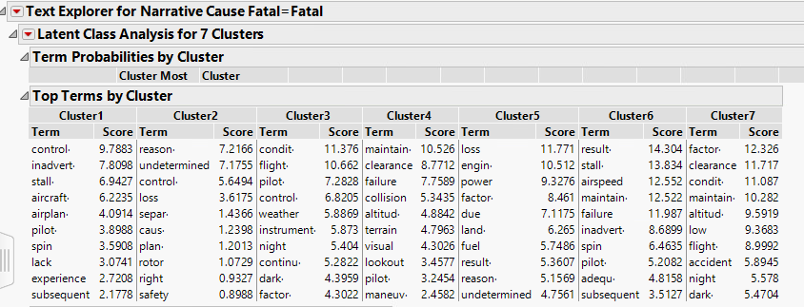 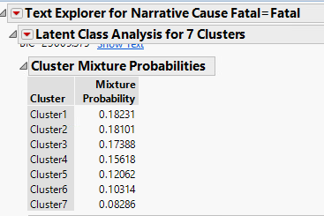

Fig(2-a) Fig(2-b)

Fig(2-a) shows clusters of **documents** which are related with same topics. **Score** of **each term** in each cluster reflects the importance of that particular term in defining meaning from respective cluster. **Top 10** most important term from every cluster has been shown. Documents have been clustered with respect to similarity of topics in between documents**. Probability*100** in (Fig 2-b) shows **%** of total **documents** in each term. Here each of 7 reasons has been derived from different 7 clusters (e.g: **Reason 1 from Cluster** 1)

* **Reason 1** Explanation: Terms like ‘lack’, ‘experience’, ‘pilot-’,’control’,’aircraft’ from **cluster 1**suggest “**lack of pilot’s experience to control aircraft**” as a reason. Terms like ‘subsequent’, ‘inadequate’, ’stall’ suggest “**subsequent inadequate stall”**. Combining this two, we get **“Lack of pilot’s experience to control aircraft and subsequent inadequate stall’ as a reason.**
* **Reason 2** Explanation: Terms as ‘separ-‘, ‘plan-‘, ‘safety’, ‘undetermined’ from **cluster 2** suggest **“Undetermined separate plan for safety”** as reason. Terms like ‘rotor’, ‘right’, ‘control’, ‘loss’ suggest **“and loss of control due to failure of right rotor resulted in fatal accident.”** as separate reason. Combining this two reason we get **Reason 2** as a cause for Fatal Accident.
* **Reason 3** Explanation: Terms like ‘condit-’, flight-’, ‘instrument-’ from **cluster 3** suggest “**bad condition of flight instrument”** as reason. Terms like ‘Pilot’, ‘continu-’,’night’,’dark’, ‘control’ suggest **“pilot’s decision to continue fly without control despite of dark night and bad weather”.** Combining these two, we **get “Harsh condition of flight instruments and pilot’s decision to continue fly without control despite of dark night and bad weather resulted in fatal accident.”** as **Reason 3** for Fatal accident.
* **Reason 4** Explanation: Terms like ‘failure’, ‘maintain’, ‘clearance’, ’terrain’ from **cluster 3** suggest **“Failure to maintain clearance from terrain”** as a reason. Terms like ‘failure’, ‘visual’, ‘lookout’ suggest **“failure to maintain visual lookout by two pilot at altitude which resulted in collision of two aircraft”** as reason. Combining these two, we get “**Failure to maintain clearance from terrain, failure to maintain visual lookout by two pilot at altitude which resulted in collision of two aircraft-fatal accident”** as a **reason 4** for Fatal accidents.
* **Reason 5** Explanation: Terms like ‘land’,’fuel’,’undetermined’,’reason’,’fuel’ from **cluster 5** cites “**Fast Landing due to Exhaustion of fuel and undetermined reason behind loss of engine power”** as **reason 5** for Fatal accidents. Terms like ‘engine’, ‘loss’, ‘power’, ‘fuel’ cites “**loss of power in engine due to lack of fuel supply**” as reason which has already been cited above
* **Reason 6** Explanation: Terms like ‘failure’, ‘maintain-’, ‘adequa-’, ’airspeed’ from cluster 6 cites “**Pilot’s failure to maintain adequate airspeed”** as **reason 6** for fatal accident. Terms like ‘subsequent’, ‘inadvert-’, ‘spin’, ’stall’ cites **“subsequent inadvertent spin/stall”** as a reason which has already been cited above in Reason 1.
* **Reason 7** Explanation: Terms like flight’,’altitude’,’maintain-‘,’clearance’ from **cluster 7** suggest “**Flight at low altitude failed to maintain clearance from ground”** as a reason. Terms like ’dark’, ‘night’ suggest **“dark night visual**” as a reason. Combining these two, we get, **“Flight at low altitude failed to maintain clearance from ground, dark night visual resulted in fatal accident”** as **reason 7** for accident.

**APENDIX:**

**ACCIDENTS INVOLVING FATAL INJURIES.**

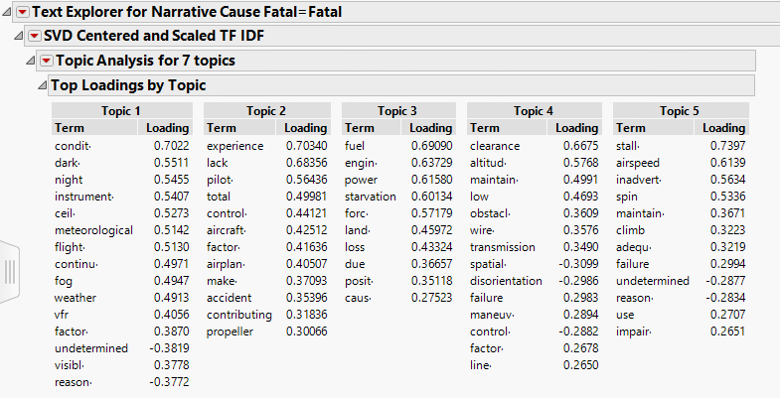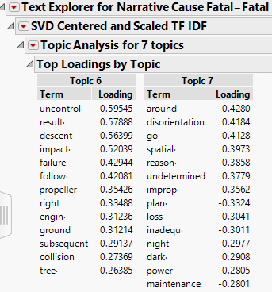

Figure 3

Figure 3 shows 7 key topics from different documents for accidents with Fatal injuries. Different document might share similar topics. Clusters shown in Fig(2-a) has been created based on this topics. Any cluster represents information about group documents which share similarity in topics.

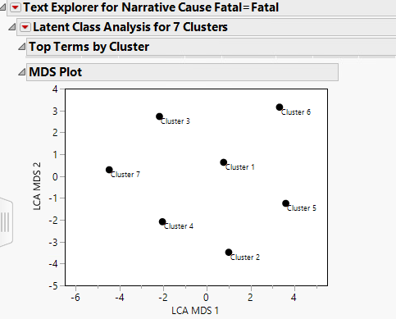 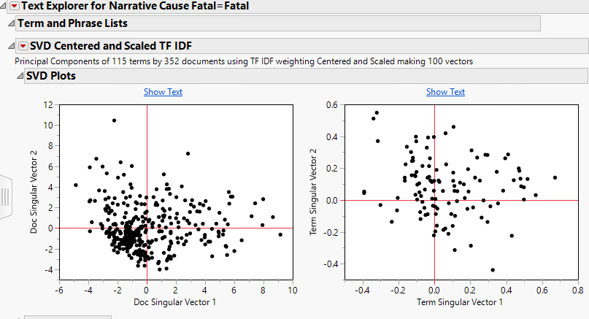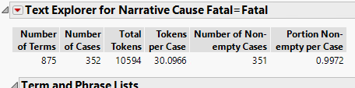

Fig(4-1) Fig(4-2) Fig(4-3)

Fig(4-1) shows LCA MDS plot for clusters. Here, We can see that clusters are neither too far nor too close from each other which shows no sign of worry about analysis of accidents which involve fatal injuries. SVD plots shows less number of outliers in Fig(4-2), which needs to be taken care of. Fig(4-3) shows number of terms(875) and other exploratory analysis of text data.

**ACCIDENTS INVOLVING NON-FATAL INJURIES**

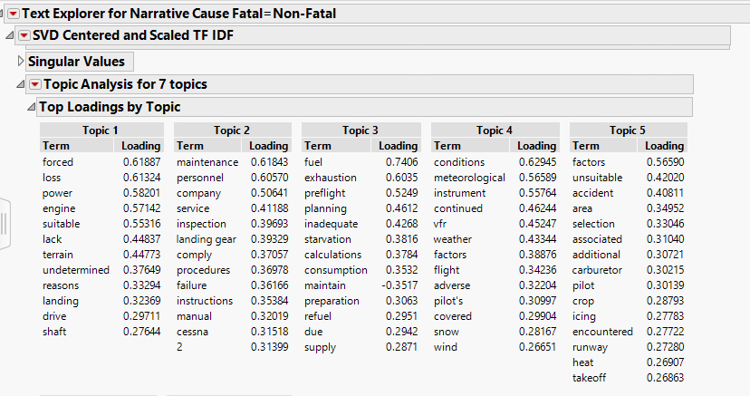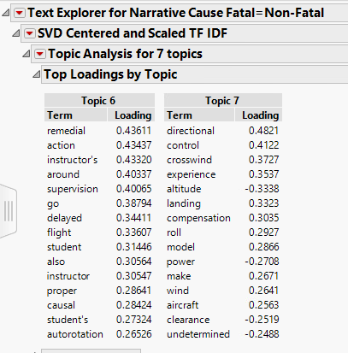

Fig-5

Figure 3 shows 7 key topics from different documents for accidents involving Non-Fatal injuries. Different document might share similar topics. Clusters shown in Fig(1-a) has been created based on this topics. Any cluster represents information about group of documents which share similarity in topics.

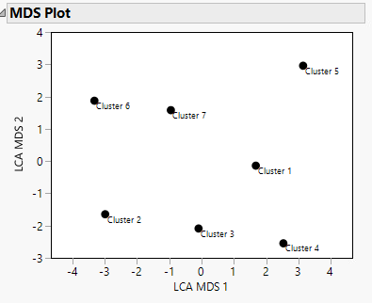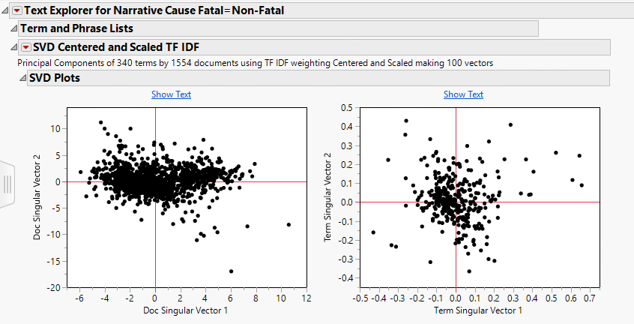

Fig(5-1) Fig(5-2)

Fig(5-1) shows LCA MDS plot for clusters. Here, We can see that clusters are neither too far nor too close from each other which shows no sign of worry about analysis of accidents which involve fatal injuries. SVD plots shows less number of outliers in Fig(5-2), which needs to be taken care of

Comment: Provide descriptive statistics and graphs.

Describe the data used for analysis

Word cloud.